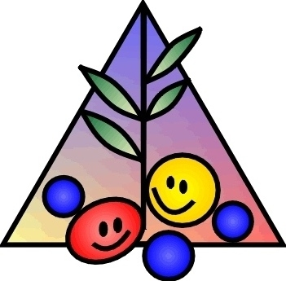
2020 competition of instrumental music for students
Märjamaa Music and Art School invites children and up to 19 years old students to participate in the competition of musical own-creation.

The aim of the competition is
-to encourage children to create something themselves
-to put their musical skills and knowledge in practise
-to estabilish creative relationships with other schools
-to build self-confidence and assurance of the performance of the young performers
Order of the competition
The competiton is going to take place in two rounds: the selection and the final
- The deadline of composites is March 1st 2020 to the following address:
Märjamaa Music and Art School
Pihlaka Street 2
78302 Märjamaa
Estonia
Keyword „The Music Competition“
- The Final Round takes place on April 3th 2020 in Märjamaa Culture House on Sauna Street 2, Märjamaa, Estonia.
All participants who make it to the Final Round will be informed by March 23th 2020 by letter or by e-mail
The competition will take place in three age-groups:
- Up to 11 years
- from 12 to 14 years
- from 15 to 19 years
The age will be taken into account as of March 1st 2020

The Compositions can be made for all instruments as solo, as solo by accompaniment in piano or as piece in groups.
The minimal length of the pieces have to be 16 bars.
Number of pieces is not limited per one author.
There has to be filled registration form along with presented piece.
The pieces sent to the competition have to be executed in computer graphics and be printed out and saved on the memory-stick or CD (DVD) as format mp3.
Accompaniment have to be also written by notes, not only by chord symbols.
In the Final Round all pieces will be performed in live, it will be the responsibility of the participants.
On stage we only proovide the grand piano, all ohter necessary instruments have to be taken along by participants.

Jury and evaluation

All pieces presented to this comptetition will be heard over by a Jury that has been put up by the organisers, the Jury will make a selection of pieces that go to Finals.
In the Jury of the Final Round will be the representatives of the teachers and students of the Music and Art School Märjamaa and a neutral expert from outside of school.

Awards

There will be a diploma for each participant in Final Round , the letters of honour to the three best author in each age-group. The Jury has right to give out special prizes.

Attendance fee

The attendance fee is 5 (five) euros for each author addmited to Final Round. This fee will be payd on April 3th 2020 in Märjamaa Culture House.
All others cost will be covered by participants.

APPLICATION FORM

- Name of author (by capital letters)
……………………………………………………………………………………………………………………………………………………………………………………………………………………………………
- Date of the birth
………………………………………………………………………………………………………………...
- Address, Phone number, e-mail address
………………………………………………………………………………………………………………………………………………..…………………………………………………………………………………
- Educational institution, class
………………………………………………………………………………………………………………………………………………..…………………………………………………………………………………………………………………………………………….........................................................
- Musicschool, speciality, class, teacher
………………………………………………………………………………………………………………..
…………………………………………………………………………………………………………………
- Age-group
…………………………………………………………………………………………………………………
- Titel of the piece and the performer or performers
………………………………………………………………………………………………………………………………………………..………………………………………………………………………………….…………………………………………………………………………………………………………………
- Supervisor
…………………………………………………………………………………………………………………
- Author of the accompaniment or of the arrangement
……………………………………………………………………………………………………………………………………………………………………………………………………………………………………

